Food preference of *Scomberoides commersonnianus* and *S. tol* in the northern Arabian Sea coast of Pakistan

Nazia Qamar1, Sher Panhwar1, and Ralf Riedel2*

1Center of Excellence in Marine Biology, University of Karachi, Pakistan

2University of Southern Mississippi, Mississippi, USA

*corresponding author

[ralf.riedel@usm.edu](mailto:ralf.riedel@usm.edu)

228-334-5332

229 Eastland Blvd.

Ocean Springs, MS 39564

USA

# Abstract

Key words: fisheries, Pakistan, carangidae, feeding

# Introduction

Knowledge of interactions between predator and prey has been recognized as essential in shaping fish communities () and necessary for improving reliability of fisheiries management, especially management taking consideration ecosystems (Bax 1994). Interactions between predator and prey may raise two concerns for fisheries management. The first one are direct effects leading to variation in food resources and the second are indirect effects causing changes in ecosystem functioning. “Trophic interactions raises two concerns for fisheries management. The first one is decline in the food resource …” <http://icesjms.oxfordjournals.org/content/62/3/430.full>. Talk about both and end with foraging patterns.

Foraging patterns in fish may reveal patterns determining trophic interactions, which in turn may guide in management of fisheries resources. Management has been single spp, but now is recognized as multispp. Multispp is the base for EBM, but needs data. EBM is better, so much so that it has been recognized by global institutions. EBM, Reykjavik declaration of 2001 and the World Summit on Sustainable Development in Johannesburg and Rio +20.

Importance of carangids to Pakistani fisheries (economy and ecology). Need data on landings and sales, preferably in comparison with other landed species of fish/shellfish.

Significance of stomach content studies to fishery science. Absence of data in Pakistan to allow effective stock assessments.

This study is a start to bridge the gap between data and information to allow resource managers to prioritize conservation and regulation practices

# Methods

## Study area and sampling

Seven hundred and ninety specimens of *S. commersonnianus* and *S. tol* were obtained from port landings at the Karachi Harbor between July 2013 and June 2014. Fish sampled were caught by purse-seines, gillnets, and trawls at depths ranging from 5 to 50 m (Figure 1). Approximately 15 specimens of each species were obtained monthly between November and January, and over 25 (except June for *S. tol*) for the remainder of the sampling period. Specimens of *S. tol* were slightly more abundant from port samplings (Table 1).

## Fish processing and Statistical Analyses

Fish obtained were stored in ice and taken to laboratory within one hour for processing. Each fish was sexed, measured to the nearest millimeter, and weighed to the nearest gram. Stomach content for each fish was removed and weighed to the nearest gram. Stomachs were emptied and re-weighed to obtain the weight of contents. Stomach contents were placed in a petri dish for examination under a microscope. Number and weight of each prey item were recorded for each stomach. Identification of prey items was done to the lowest possible taxa.

Analysis of prey composition was done to assess patterns of feeding according to species, life stage, gender, and weather. Weather was taken as either rainy or dry, according to whether the sampling occurred during monsoon months or outside such period, respectively. Life stage was either juvenile or adult. Life stage was obtained from examining modes of length plots.

Because data from each specimen yielded multiple prey taxa, we opted to analyze patterns of prey composition using multivariate statistical methods. Prey composition was examined using permutational analysis of variance (permanova) on factors denoting species, life stage, gender, and weather, all with two levels as indicated above. Fish with empty stomachs were not included in analysis for prey composition. Permanova was chosen due to relaxation of data homoschedasticity as an underlying assumption of analysis. The Bray-Curtis distance matrix was used as the basis for estimating effect size and significance of factors.

Patterns of fish with no feeding activity were estimated using empty stomachs as a surrogate. Activity was examined using binomial logistic regression. Fish were coded as either 0 (empty stomach) or 1 (content present). Codes were taken as the response variable. The independent variables were as above for the permanova analysis. The link function for the regression was taken as the logit. Data were split to test for model fitting. The training set comprised of 85 percent of the data and the remainder of data was assigned to the testing set. Drop of deviance from the regression analysis was used to assess the effect of the independent variables in determining the response. To analyze drop in deviance, a chi-square analysis of variance was used. In addition to model fitting, model predictive ability was also assessed. Predictive ability was tested with the testing dataset using a decision boundary probability of 0.5. The area under the curve of a Receiving Operating Characteristic plot was used as an additional test for model predictability.

# Results

Length plots indicated that adult fish for both species were larger than approximately 30 cm (Figure 2). Permanova results showed that consumed prey biomass was a function of species, life stage, and weather. For both species, juveniles consumed less prey. Fish was the predominant prey for *S. commersiannus* and crustaceans for *S. tol*. On average, *S. commersiannus* consumed more prey by weight than *S. tol*. (Figure 3).

Age class and fish species were the only factors influencing feeding inactivity, as measured by stomach emptiness. Logistic regression results showed that juveniles and *S. tol* were more likely to have empty stomachs. Weather and gender did not influence patterns of stomach emptiness. Regression model from the testing data showed an accuracy of 82 percent correct estimates of emptiness (Table 3). The area under the curve for the ROC plot was 0.69 (Figure 4).

# Discussion

# References

# Tables

## Table 1. Quantity of *Scomberoides commersiannus* (A) and *S. tol* (B) sampled from Karachi Harbor, Pakistan, landings for stomach content analysis.

|  |  |  |
| --- | --- | --- |
| Month | A | B |
| Jan | 13 | 18 |
| Feb | 37 | 34 |
| Mar | 28 | 59 |
| Apr | 36 | 45 |
| May | 43 | 44 |
| Jun | 44 | 17 |
| Jul | 32 | 34 |
| Aug | 49 | 35 |
| Sep | 47 | 36 |
| Oct | 33 | 49 |
| Nov | 14 | 14 |
| Dec | 13 | 16 |
| Totals | 389 | 401 |

## Table 2. Permanova output table showing results of prey biomass on species, gender, life stage, and weather for *Scomberoides commersiannus* and *S. tol* sampled from landings in Pakistan between July 2013 and June 2014

|  |  |  |  |  |  |
| --- | --- | --- | --- | --- | --- |
| Source | df | SS | MS | Pseudo-F | P(perm) |
| species | 1 | 26361 | 26361 | 6.8208 | 0.001 |
| stage | 1 | 28115 | 28115 | 7.2746 | 0.001 |
| gender | 1 | 3742.4 | 3742.4 | 0.96832 | 0.424 |
| weather | 1 | 17972 | 17972 | 4.65 | 0.001 |
| Fi x st | 1 | 12298 | 12298 | 3.182 | 0.011 |
| Fi x se | 1 | 4007.5 | 4007.5 | 1.0369 | 0.413 |
| Fi x ra | 1 | 4464.5 | 4464.5 | 1.1552 | 0.305 |
| St x ra | 1 | 8379.9 | 8379.9 | 2.1682 | 0.033 |
| Se x ra | 1 | 3501.8 | 3501.8 | 0.90606 | 0.491 |
| Res | 575 | 2.2223E6 | 3864.8 |  |  |
| Total | 584 | 2.3574E6 |  |  |  |

## Table 3. Binomial logistic regression and analysis of deviance table showing results of stomach emptiness on species, gender, life stage, and weather for *Scomberoides commersiannus* and *S. tol* sampled from landings in Pakistan between July 2013 and June 2014. (need to clean this up a lot, but it shows the analysis output)

Deviance Residuals:

Min 1Q Median 3Q Max

-2.4480 0.3202 0.4167 0.6102 0.8337

Coefficients:

Estimate Std. Error z value Pr(>|z|)

(Intercept) 1.6542 0.3219 5.139 2.76e-07 ***

fishspptol 1.1272 0.2344 4.809 1.52e-06 ***

rainlow 0.1637 0.2364 0.692 0.4887

ageclassjuvenile -0.5448 0.2326 -2.342 0.0192 *

genderM -0.2312 0.2315 -0.999 0.3179

---

Signif. codes: 0 ‘***’ 0.001 ‘**’ 0.01 ‘*’ 0.05 ‘.’ 0.1 ‘ ’ 1

(Dispersion parameter for binomial family taken to be 1)

Null deviance: 644.30 on 799 degrees of freedom

Residual deviance: 597.22 on 795 degrees of freedom

AIC: 607.22

Number of Fisher Scoring iterations: 5

Analysis of Deviance Table

Model: binomial, link: logit

Response: content

Terms added sequentially (first to last)

Df Deviance Resid. Df Resid. Dev Pr(>Chi)

NULL 799 644.30

fishspp 1 38.687 798 605.61 4.974e-10 ***

rain 1 0.937 797 604.68 0.33304

ageclass 1 6.448 796 598.23 0.01111 *

gender 1 1.004 795 597.22 0.31624

---

Signif. codes: 0 ‘***’ 0.001 ‘**’ 0.01 ‘*’ 0.05 ‘.’ 0.1 ‘ ’ 1

# Figures

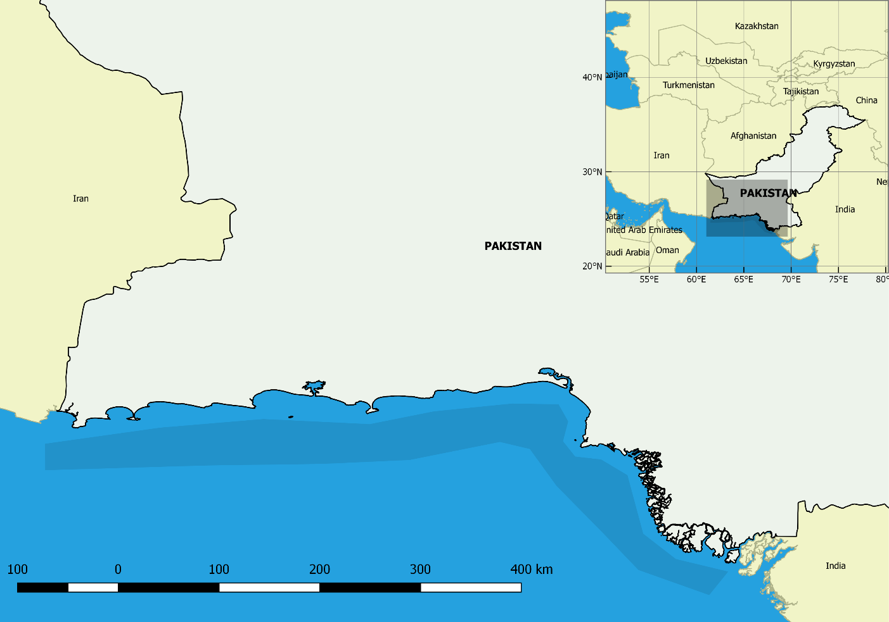

## Figure 1. Study area of feeding patterns of *Scomberoides commersiannus* and *S. tol*; shaded area along coast indicates location of commercial fishing grounds.

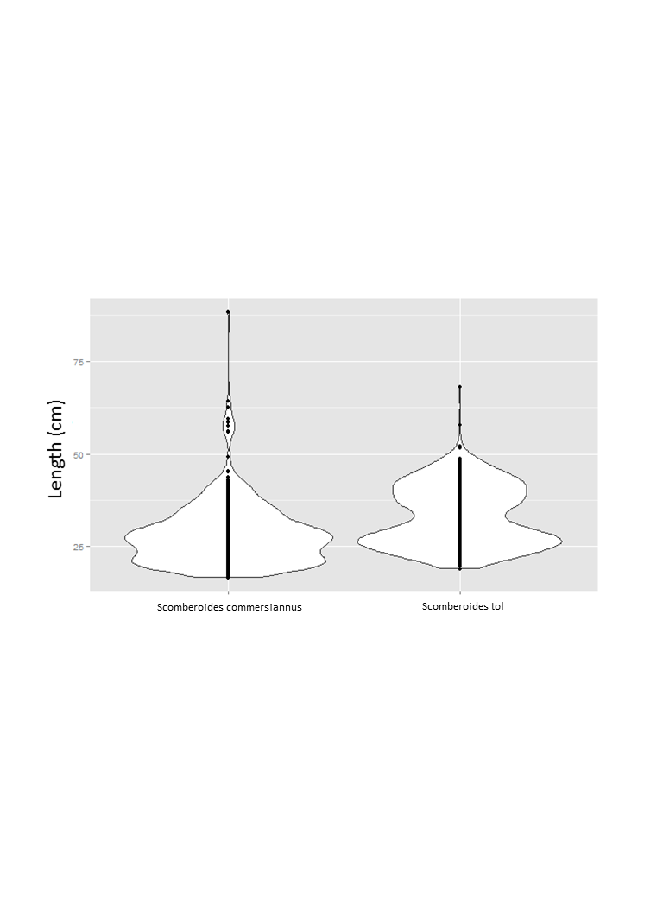

## Figure 2. Violin plot of length distribution of *Scomberoides commersiannus* and *S. tol* sampled along the Pakistani coast;

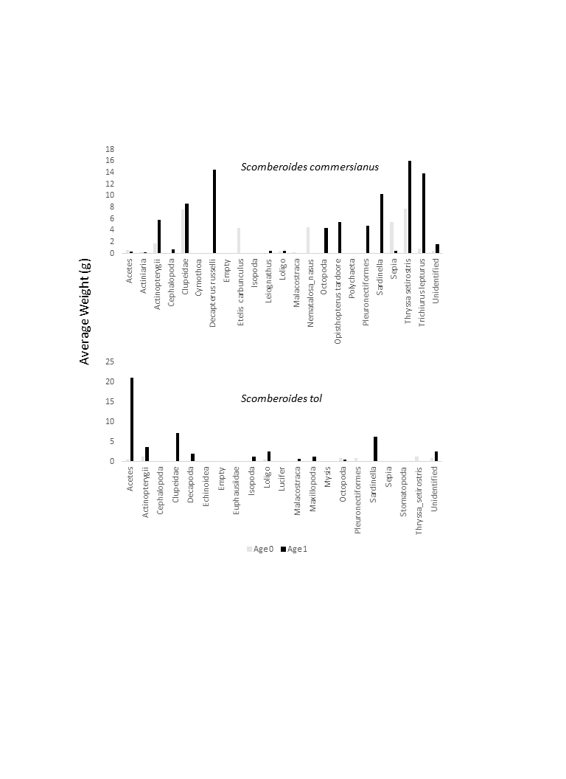

## Figure 3. Average weight of prey items in stomach of *Scomberoides commersiannus* and *S. tol* sampled from landings in Pakistan between July 2013 and June 2014. (need to add Cis and panels for rain/dry season)

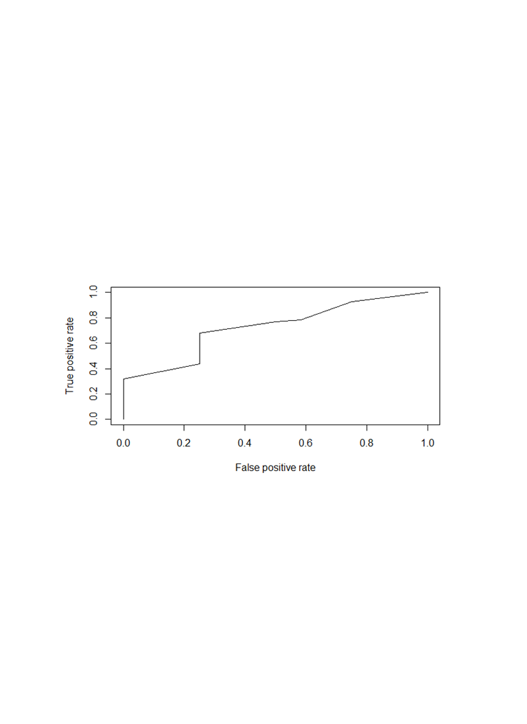

## Figure 4. Receiver operating characteristic plot indicating performance of binomial logistic regression of stomach emptiness on species, gender, life stage, and weather for *Scomberoides commersiannus* and *S. tol* sampled from landings in Pakistan between July 2013 and June 2014.